Ordinary Level Questions 2015

1.
The points P and Q lie on a straight level road.
A car passes P with a speed of 24 m s^{‒1} and decelerates uniformly for 4 seconds to a speed of 8 m s^{‒1}.
The car now accelerates uniformly from 8 m s^{‒1} to a speed of 26 m s^{‒1}.
The car travels 102 metres while accelerating.
It now continues at a constant speed of 26 m s^{‒1} for 10 seconds and then passes Q.

(a)
Find
- the deceleration
- the acceleration
- |PQ|, the distance from P to Q
- the average speed of the car between P and Q.

(b)
There is a legal speed limit of 100 km h^{‒1} on this road.
Investigate if the car exceeds the speed limit as it travels from P to Q.

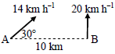
2.
Ship A is travelling east 30° north at a constant speed of 14 km h^{‒1}.
Ship B is travelling due north at a constant speed of 20 km h^{‒1}.
B is positioned 10 km due east of A.
- Express the velocity of A and the velocity of B in terms of i and j.
- Find the velocity of A relative to B in terms of i and j.
- Calculate the shortest distance between the ships in their subsequent motion.
- Find the distance between the ships one hour after the instant that they were closest together.

3.
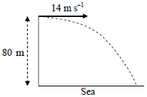
(a)
A particle is projected horizontally with an initial speed of 14 m s^{‒1} from the top of a straight vertical cliff of height 80 m.
How far from the foot of the cliff will it hit the sea?

(b)
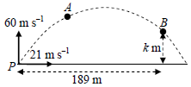
A particle is projected with initial velocity 21 i + 60 j m s^{‒1} from point P on a horizontal plane.

A and B are two points on the trajectory (path) of the particle.
The particle reaches point A after 4 seconds of motion.
The displacement of point B from P is 189 i + k j m.
Find
- the velocity of the particle at A in terms of i and j
- the speed and direction of the particle at A
- the value of k.

4.
(a)
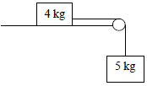
A particle of mass 4 kg is connected to another particle of mass 5 kg by a taut light inelastic string which passes over a light smooth pulley at the edge of a rough horizontal table.
The coefficient of friction between the 4 kg mass and the table is $\frac{3}{4}$.

The system is released from rest.
- Show on separate diagrams the forces acting on each particle.
- Find the common acceleration of the particles.
- Find the tension in the string.

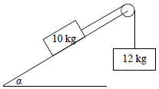
(b)
Masses of 10 kg and 12 kg are connected by a taut light inelastic string which passes over a light smooth pulley, as shown in the diagram.
The 10 kg mass lies on a smooth plane inclined at α to the horizontal, where tan α = $\frac{4}{3}$.
The 12 kg mass hangs vertically.
The system is released from rest.
Find
- the common acceleration of the particles
- the tension in the string.

5.
(a)
A smooth sphere A, of mass 5 kg, collides directly with another smooth sphere B, of mass 6 kg, on a smooth horizontal table.
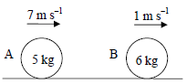
A and B are moving in the same direction with speeds of 7 m s^{‒1} and 1 m s^{‒1}, respectively.
The coefficient of restitution for the collision is $\frac{5}{6}$.
Find
- the speed of A and the speed of B after the collision
- the loss in kinetic energy due to the collision
- the magnitude of the impulse imparted to A due to the collision.

(b)
A ball is dropped from rest from a height of 3.2 m onto a smooth horizontal floor.
The ball hits the floor and rebounds to a height of h metres above the floor.
The coefficient of restitution between the ball and the floor is $\frac{3}{5}$.
Find
- the speed of the ball when it hits the floor
- the value of h.

6.
(a)
Particles of weight 5 N, 9 N, 6 N and 1 N are placed at the points (p, 5), (7, q), (‒6, ‒q) and (5, 8) respectively.
The co-ordinates of the centre of gravity of the system are (p, p).
Find
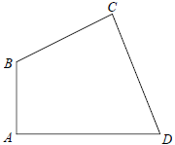
- the value of p
- the value of q.

(b)
A quadrilateral lamina has vertices A, B, C and D.
The co-ordinates of the vertices are A(0, 0), B(0, 9), C(12, 15) and D(18, 0).
Find the co-ordinates of the centre of gravity of the lamina.

7.
(a)
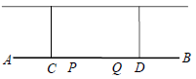
A uniform beam, AB, is held in a horizontal position by two vertical inelastic strings attached at the points C and D respectively.
The weight of the beam is 20 N and the length of the beam is 4 m.
A particle of weight 18 N is placed at point P on the beam and another particle of weight 10 N is placed at point Q on the beam.
|AC| = |BD| = 1 m and |CP| = |QD| = $\frac{1}{2}$ m.
Calculate the tension in each of the strings.
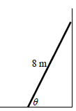
(b)
A uniform ladder, of weight 160 N, is resting on rough horizontal ground and leaning against a smooth vertical wall.
The length of the ladder is 8 m.
The ladder makes an angle θ with the ground, where tan θ = $\frac{35}{12}$.
The ladder is in equilibrium and is on the point of slipping.
Find the coefficient of friction between the ladder and the ground.

8.
(a)
A particle describes a horizontal circle of radius 2 m with uniform angular velocity ω radians per second.
The particle completes 10 revolutions every minute.
Find
- the value of ω
- the speed and acceleration of the particle

(b)
A smooth particle of mass 2 kg is attached by a light inelastic string to a fixed point P.
The particle describes a horizontal circle of radius 0.25 m on the smooth surface of a horizontal table.
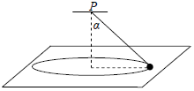
The centre of the circle is vertically below P.
The string makes an angle α with the vertical, where tan α =$\frac{4}{3}$.
The speed of the particle is 1.2 m s^{‒1}.
Find
- the tension in the string
- the reaction force between the particle and the table.
9.
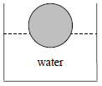
(a)
A solid sphere floats at rest in water.
The radius of the sphere is 12 cm.
25% of the volume of the sphere lies below the surface of the water.
Find the weight of the sphere, correct to the nearest newton.
[Density of water = 1000 kg m^{–3}]
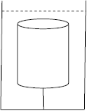
(b)
A right circular solid cylinder has a height of 15 cm and a radius of 4 cm.
The relative density of the cylinder is 0.8 and it is completely immersed in a tank of liquid of relative density 1.2.
The cylinder is held at rest by a light inelastic vertical string which is attached to the base of the tank.
The upper surface of the cylinder is horizontal.
Find the tension in the string, correct to the nearest newton.

